Websites Specifications

- Website objectives and goals in relation to the business
The objective of the website is to create a global ecosystem called Study With Me where undergraduates can collaborate with one another regardless of their university or location. It allows students in the same field to study to foster a high focus collaborative environment and strive for academic excellence together.
The goals are as follows;
Peer engagement across the world and transition from isolated learning to a global collaborative community:
This allows students from different universities, in the same fields (engineering and health sciences) to find one another. The goal is to ensure that regardless of where they are studying from, they engage in a collaborative environment from isolated learning to a shared “Study With Me” culture.

- INFORMATION DESIGN & TAXONOMY

The website is made in such a way that it allows undergraduates to connect based on their course of study. They can directly select from the homepage and access the global course hub where they can interact, study and share resources.
Site Map:
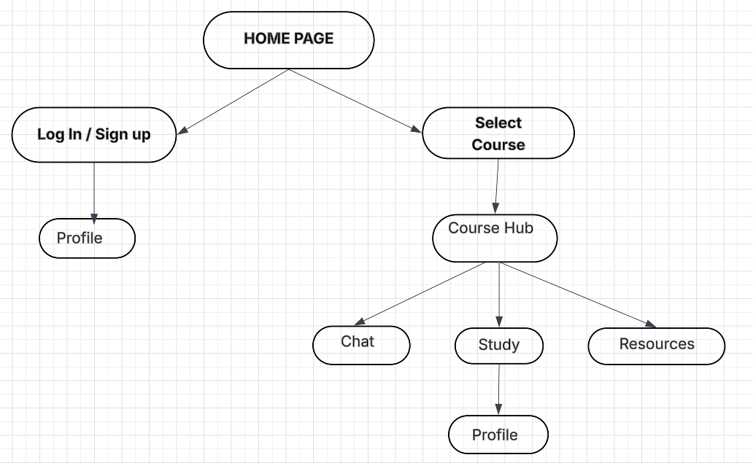

- TECHNICAL BRIEF
The website will be developed using HTML and CSS to create and design the structure and layout of the platform. Visual Studio Code will be used for writing and editing whereas GitHub will be used to manage and store project files. These applications are good for the project because they are reliable and allow the creation of a functional and user-friendly platform that supports student collaboration and interaction.

